Tour name: 4-Day Discovery of Turkmenistan: From Marble City to Sacred Mountains
Tour description: Discover the essence of Turkmenistan on this immersive 4-day journey through its striking capital, sacred mountain landscapes, desert wonders, and cultural heritage. From the white-marble grandeur of Ashgabat to the burning Darvaza Gas Crater and the preserved traditions of Nohur village, this itinerary offers a rich combination of history, nature, and authentic local character.
Starting Point: Ashgabat International Airport
Ending Point: Ashgabat International Airport
Note: The starting and ending points of the itinerary may be adjusted depending on the client’s request, logistics, and tour format.
Group Size: 3+
Duration: 4 Days
Price: From 710 USD per person
Pricing note: The tour price depends on the number of participants. The more people join the tour, the lower the price per person will be.
Day 1 | Arrival in Ashgabat: The White-Marble Capital  Arrival at Ashgabat International Airport, where you will be met by your guide and transferred to the city.  Your journey begins with an introduction to Ashgabat, the capital of Turkmenistan, famous for its monumental architecture, broad avenues, immaculate urban planning, and white-marble facades. The first sightseeing visits include the Independence Monument, one of the most important national symbols of the country, and the Neutrality Monument, one of Ashgabat’s most iconic landmarks.  Continue to the Alem Cultural and Entertainment Center to see the famous indoor Ferris wheel, an impressive modern attraction that reflects the city’s ambitious architectural style. You will also visit the Memorial Complex, dedicated to key moments and figures in the nation’s history.  In the evening, enjoy a panoramic night tour of Ashgabat, when the city reveals a completely different atmosphere through its illuminated boulevards, marble buildings, and impressive monuments.  Overnight at a hotel in Ashgabat.  Distance of the day: approx. 30–50 km
Day 2 | Ashgabat – Old Nisa – Akhal-Teke Horses – Ruhy Mosque – Darvaza  After breakfast, continue exploring the historical and cultural highlights of Ashgabat and its surroundings.  Begin with a visit to the National Museum of Turkmenistan, which provides an excellent introduction to the country’s rich past, archaeology, ethnography, and traditions. Then proceed to Old Nisa, a UNESCO World Heritage Site and one of the most significant archaeological monuments in Central Asia. Once a royal residence of the Parthian Empire, Nisa offers a fascinating insight into one of the great civilizations of the ancient world.  The tour continues with a visit to the Akhal-Teke horse stables, where you will see Turkmenistan’s most celebrated national symbol. Known for their elegance, intelligence, endurance, and distinctive metallic sheen, Akhal-Teke horses are considered among the oldest and most beautiful horse breeds in the world.  Next, visit the grand Turkmenbashi Ruhy Mosque in Gypjak, one of the largest mosques in Central Asia and an important spiritual landmark of modern Turkmenistan.  After lunch, depart Ashgabat and drive north through the Karakum Desert toward Darvaza. By evening, arrive at the famous Darvaza Gas Crater, often referred to as the “Door to Hell.” The glowing crater in the middle of the desert creates one of the most unforgettable natural scenes in the region.  Enjoy a barbecue dinner near the crater and experience the dramatic atmosphere of the desert under the stars.  Overnight in tents/yurt-style desert camp near Darvaza.  Distance of the day: approx. 300 km
Day 3 | Darvaza – Ashgabat  Wake up early to experience the peaceful desert morning and the unique scenery of Darvaza in daylight. After breakfast at the camp, depart for the return drive to Ashgabat.  Upon arrival in the capital, enjoy lunch at a local restaurant. In the afternoon, continue with a more relaxed part of the city program. Visit Lenin Park, one of Ashgabat’s green public spaces, offering a calmer contrast to the city’s monumental avenues and modern architecture.  Later, visit the Ertugrul Gazi Mosque, one of Ashgabat’s most elegant religious landmarks, notable for its Ottoman-inspired design and refined architectural details.  The rest of the evening is free for rest, independent прогулки, or another optional walk through the illuminated city center.  Overnight at a hotel in Ashgabat.  Distance of the day: approx. 280 km
Day 4 | Ashgabat – Nohur Village – Kow Ata Underground Lake – Departure  After breakfast, depart for the scenic mountain region southwest of Ashgabat.  Drive into the Kopetdag foothills to visit Nohur, a remote mountain village known for its distinctive customs, traditional way of life, and beautiful natural surroundings. This area offers a very different perspective on Turkmenistan, far from the monumental capital and desert landscapes. Nohur is especially interesting for its preserved local culture, quiet mountain atmosphere, and panoramic views.  Continue to Kow Ata Underground Lake, a remarkable natural site hidden inside a cave. The lake is known for its warm mineral-rich water and unusual underground setting. Those who wish may enjoy a swim in its naturally heated waters.  After lunch, return to Ashgabat and transfer to Ashgabat International Airport for departure.  End of the tour.  Distance of the day: approx. 180–220 km

Tour Price includes:
Meet and greet at Ashgabat International Airport with local English-speaking guide
• All transfers and transportation throughout the program
• Accommodation in hotels in Ashgabat
• 1 night desert camp accommodation near Darvaza
• 3 breakfasts
• 1 barbecue dinner at Darvaza
• Sightseeing tours and excursions as per itinerary
• Entrance fees to all sites mentioned in the program
• Visits to Independence Monument, Neutrality Monument, Alem Ferris Wheel, Memorial Complex
• Visit to the National Museum of Turkmenistan
• Excursion to Old Nisa UNESCO World Heritage Site
• Visit to the Akhal-Teke horse stables
• Visit to Turkmenbashi Ruhy Mosque
• Visit to Ertugrul Gazi Mosque
• Excursion to Nohur village
• Visit to Kow Ata Underground Lake
• Darvaza Gas Crater excursion
• Bottled water during the tour
• Invitation letter

Tour Price NOT includes:
• International flights
• Lunches and dinners, except where specified in the program
• Turkmenistan tourist visa fee and migration charges
• Personal expenses
• Tips for guide and driver
• Optional activities not mentioned in the itinerary
• Hotel early check-in or late check-out, unless specified
• Charges for additional hotel services
• Travel insurance

Some photos from tour:
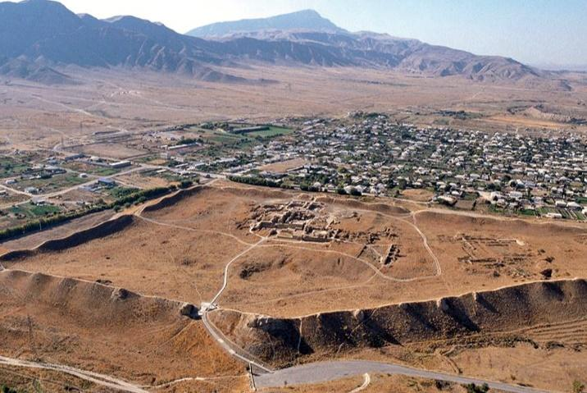
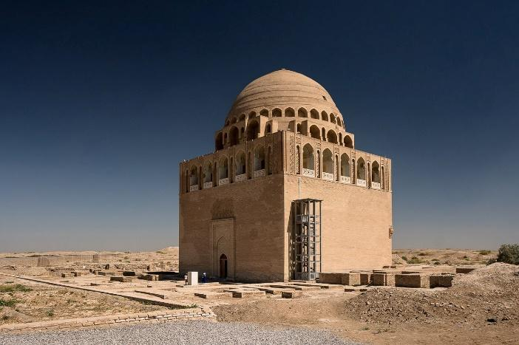
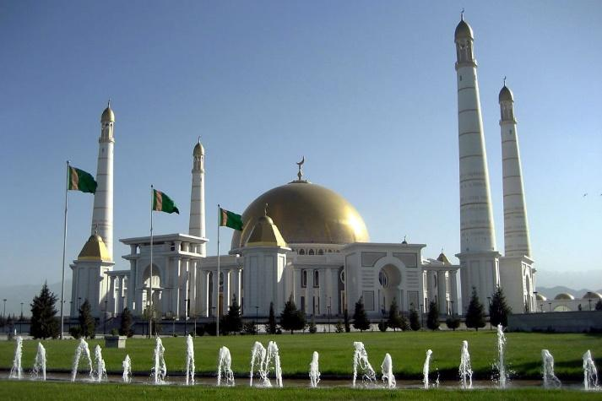

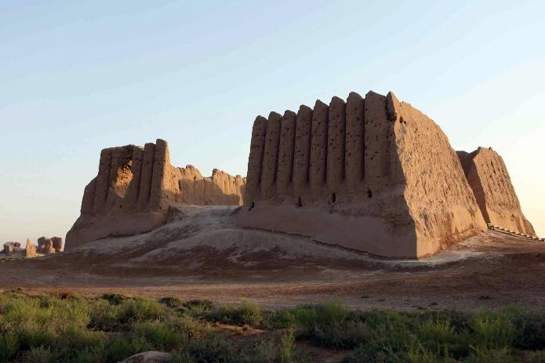

Notes
• The price is based on a minimum group size of 3 participants.
• The tour can also be organized starting from Ashgabat, Farap, or Shavat border upon request.
• The itinerary may be adjusted depending on flight schedule, weather conditions, and road conditions.

